Project Overview:
Objective:
Design and prototype a multi-agent agentic system to support a Research Analyst working in the health enquiries domain. The system must handle research tasks, retrieve and summarize information, reflect on results, and interact using a structured, explainable workflow.

Core Capabilities:
- Multi-agent architecture (max 5 agents)
- Naïve RAG (Retrieval-Augmented Generation)
- Reflective agent with introspection
- Routing & planning
- UML diagrams (Component + Interaction)
- Streamlit frontend & CrewAI-based prototype
- Chromadb knowledge store

Proposed Multi-Agent Architecture:
Level 1: Planner
- Orchestrator
Role:
- Acts as the “brain” of the system
- Breaks user queries into tasks
- Decides which worker agents to call
- Monitors workflow completion
LLM Choice: GPT-4o Mini / Mistral (fast, good reasoning)
Workflow:
- Receive query
- Decompose Search task, RAG task, summarization, reflection
- Dispatch to worker agents
- Aggregate outputs
Level 2: Worker Agents:
- Search Agent (Web + RAG Retriever)
Role:
- Performs health-domain research
- Retrieves data from Chromadb RAG store
- Conducts web search (if tool allowed)
LLM: Mistral-Small (fast retrieval reasoning)
Tools:
- Chromadb retriever (mandatory)
- Optional: Web search tool

Inputs: query from Planner
Outputs: collected documents + top-k passages

- Summarization Agent
Role:
- Summarizes search results into structured, medically coherent text
- Can use chain-of-thought style summarization
LLM: GPT-4o Mini / Mistral-Medium
Tools: None
Workflow:
- Receive retrieved chunks
- Generate:
- Abstract summary
- Bullet list
- Key insights & risks

- Reflective (Introspective) Agent
Role:
- Evaluates quality of summaries
- Checks completeness, hallucinations, tone
- Suggests improvements
- Uses a reflection metric
Metrics:
- Coherence score
- Factuality confidence (LLM self-grade 1–5)
- Completeness score
Workflow:
- Inspect summary
- Score it
- Provide revision instructions
- Summarization Agent revises (loop once)

RAG Architecture:
Knowledge Base: Chromadb
Storage format:
- documents
- chunked passages
- embeddings
Embedding Model: instructor-xl / all-MiniLM-L6-v2
Pipeline:
- Preprocess health-domain dataset
- Chunk text using 500–700 char windows
- Embed + store in Chromadb
- Search Agent queries via vector similarity
- Top-k results passed to Summarization Agent

Data Sources (Health Domain)
Example acceptable sources:
- CDC health articles
- WHO disease fact sheets
- Health Canada advisory bulletins
- PubMed abstracts
Note: Document one data source and load it into the RAG.

Knowledge Base Data Model:
Component | Description
documents | Raw scraped documents, titles, URLs
chunks | Split segments for RAG
embeddings | Vector representation
metadata | Source, date, tags
reflective logs | Reflection agent’s scoring per task

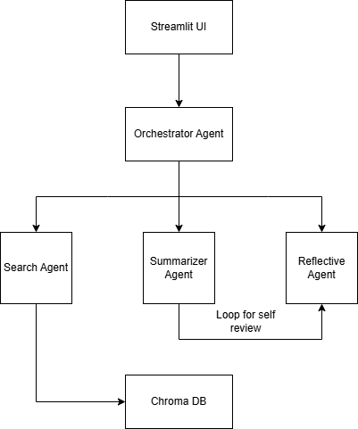
UML Component Diagram:

UML Interaction Sequence Diagram for Multi-Agent Search & Summarization System
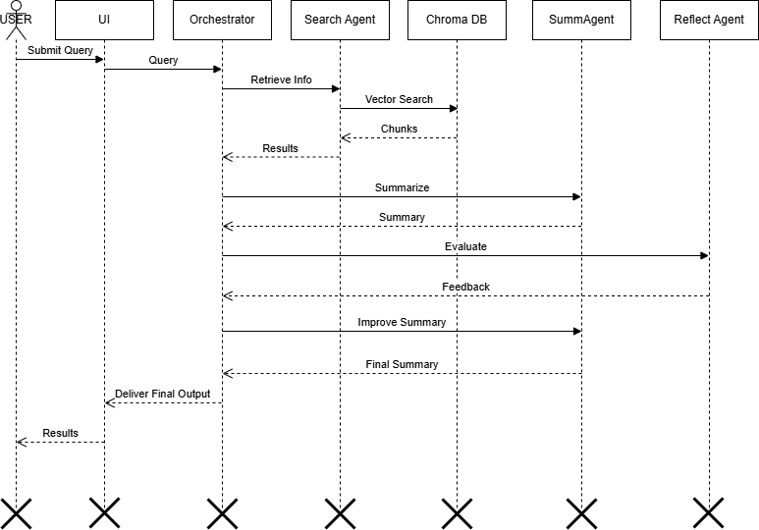

Design Decision and Trade-offs:
Privacy
- No personal health data stored
- Only public articles used
- Chromadb stored locally
Fairness
- Avoid biased medical recommendations
- Use multi-source retrieval
Explainability
- Reflective agent produces scoring + justification
- Planner logs show agent routing decisions
Responsible AI
- No diagnostic claims
- System outputs a research summary, not medical advice

